**Numerical Investigation of Thermo syphon Solar Flat Plate Collector with Back Layer of PCM**

|  |  |  |
| --- | --- | --- |
| **Mulay Suraj Tryambak**  Department of Mech. Engineering,  Govt. College of Engineering, Karad, 415124  Email: surajmulay411@gmail.com | **Waghmare A V**  Department of Mech. Engineering  AISSMS College of Engineering Pune 411044  Email: avwaghmare@gmail.com | **Pise Ashok T.**  Principal,  Govt. College of Engineering,  Karad, 415124  Email: ashokpise@yahoo.com |

**Abstract**

In the present research, performance of thermo syphon flat plate solar collector with back layer of Phase Change Material is investigated numerically at various tilt angles. In conventional collector, only sensible heat is stored in heat transfer fluid. Very low energy density & more space required for energy storage are some main limitations in conventional flat plate collector. With introducing PCM in collector, latent heat is stored and requires less space for storing same amount of energy. Boussinesq approximation is employed in computational model to capture buoyancy driven flow of heat transfer fluid. Enthalpy-porosity formulation has been used for numerical modelling of PCM. Numerical results have a good agreement with experimental result. From numerical analysis, it is observed that plate gets heated even after sun-shine period & due to this heat transfer fluid gets useful heat gain during off-sunshine period. Hence increase in total efficiency over conventional collector is noticed.

Keywords: *PCM, LHS, CFD, Thermo syphon.*

# INTRODUCTION

Solar energy is one of the important alternative energy sources which will be utilized in near future. Primary factor that affects the utility of solar energy is that it is a cyclic & time dependent. Hence solar energy system requires energy storage to provide energy during night & overcast period. Thermal Energy Storage is necessary to success of many intermittent energy sources in meeting demand. The present study focuses on the investigation of performance of thermo syphon solar flat plate collector numerically. The purpose of this study is to determine how much useful heat gain can be achieved by introducing PCM into collector at tilt angles of 17.45°, 32.45° & 50°. Numerical results are validated with experimental results. Paraffin wax is used as PCM because of advantage associated with it. There are few numerical analysis approaches such as artificial neural networks, transient simulation tool (TRNSYS) , finite element analysis (FEA) & commercial code Engineering Equation Solver (EES) mainly[6-8].

Total efficiency of solar water heater with back layer of PCM is found to be greater than that of conventional heater in all relevant studies [1-3]. Prakash et al[1] noticed that average efficiency of solar heater with PCM is 50.44% while for conventional heater is 38.04%. Carmona et al[3] created reduced model for a thermal analysis of a flat plate collector with TES using PCM. Mohsen et al [4] experimentally studied thermal analysis of compact solar water heater under local climatic conditions. Waghmare & Pise[5] studied melting & freezing behaviour of PCM numerically(2-D). Redzuan[6] et al developed CFD model for PCM integrated solar collector.

From the literature review it is found that many authors have studied PCM integrated solar water heater experimentally and numerically (2-D). No researcher has studied thermo syphon solar water heater numerically i.e., no one has captured natural convection in computational model. In the present research, a 3D CFD model is developed and analysed using Boussinesq approximation (to capture buoyancy induced flow) & enthalpy-porosity formulation.

# METHODOLOGY

The performance of flat plate collector is studied numerically & experimentally. Ansys Fluent 18.1 is used for numerical analysis. Computational domain is developed in design modeller.

## Experimental set up and test procedure

A PCM integrated solar water heater is designed & fabricated as shown in figure 1.The experiment location is at latitude 17.27°N & longitude 74.20°E .Three riser tubes are adhere to the upper surface of absorber plate .The PCM is in direct contact with the lower surface of absorber plate. During sunshine period some of solar radiation heats heat transfer fluid in riser tube & remaining solar radiation melts the PCM(often called as charging process) in PCM chamber. The configuration of riser-absorber plate-PCM chamber is designed as a heat exchanger unit which exchanges heat between heat transfer fluid and PCM. In this experiment, 10 Litre water is filled in solar tank & circulated through flat plate collector during experimentation periods. Experimental set-up is as shown in fig.1.

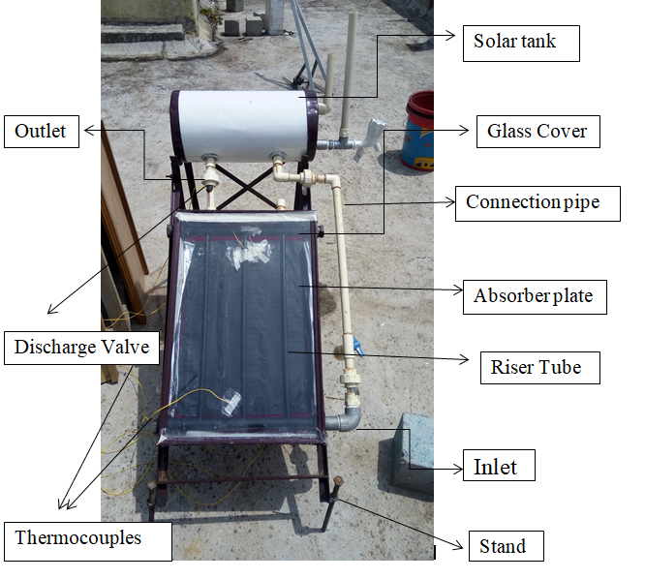

Eleven thermocouples are attached to collector for temperature measurement of inlet, outlet, different locations in PCM & on absorber plate ,glass glaze.16 channel data logger is used to capture temperature signal for experimentation period with an accuracy of 0.1°C $\underline{+}$ 0.3% .Solar intensity is measured by pyranometer with accuracy 1W/m2 0.8%.Discharge is measured by Volumetric method. The uncertainty in instantaneous efficiency is $±$ 3.41%. The dimension of flat plate collector is as shown in table 1.

**Table 1.Specification of PCM Integrated Solar Water Heater**

|  |  |  |
| --- | --- | --- |
| Specification | Description | Dimension |
| Absorber plate | Copper | 490mm $×$ 380mm $×$ 0.3mm |
| Riser tube | Copper | $∅$ 12.6 mm |
| Glass glazing | Water White | 520 mm $×$ 440mm $×$ 3mm |
| PCM chamber | Acrylic | 400mm $×$ 280mm $×$ 20mm |
| PCM | Paraffin Wax | 2 kg |
| Solar Tank | Mild Steel(insulated) | 10 litre |

## Mathematical analysis

By using the above measurements, useful heat gain, overall heat loss coefficient, efficiency factor, heat removal factor are then calculated using the basic derivation by Hottel-Bliss-Whillier[9] with some modification wherever required.

The useful energy gain of collector can be expressed as:

$Q_{u}=A_{c}F_{R}[S-U_{L}\left(T_{i}-T_{a}\right)]$ (3)

where, $A_{c}$ = Area of collector

$T_{i}$ = Inlet temp.

$T_{a}$ = Ambient temp.

S = HT()

The heat removal factor (FR) is given by:

$F_{R}=\frac{\dot{m}c_{p}}{A_{c}U_{L}}[1-\exp\left(-\frac{A_{c}U_{L}F^{'}}{\dot{m}c_{p}}\right)]$ (4)

$Q_{u}= Q_{water}+Q_{TES}$ (5)

$Q_{water}=\dot{m}c_{p}(T_{o}-T_{i})$ (6)

The instantaneous efficiency of system is given by:

$η_{i}=\frac{Q_{u}}{H_{T}A_{c}}$ (7)

**Figure 1: Experimental set up**

1. **Numerical Analysis**

For the modelling of PCM integrated solar collector following assumptions are made:

* The PCM is homogeneous & isotropic
* Thermal resistance across the wall of the thermal storage is negligible
* The phase change process is unsteady & 3-D.

To study heat transfer & fluid flow in 3D following governing equations are used for numerical formulation of Heat Transfer Flow region & PCM region.

*Governing Equation:*

Numerical formulation of the Heat transfer fluid region:

 (8)

 (9)



(10)



(11)

 (12)

Numerical formulation of the PCM region:

 (13)

 (14)

where h = sum of the sensible enthalpy.

The enthalpy change due to the phase-change :

 (15)

*Mesh generation*

Heat transfer on absorber plate and melting & solidification process in PCM is symmetric in lateral direction has been taken to treat problem as axisymmetric. Absorber plate & tube are considered as a solid zone & specified with material copper. Heat transfer fluid & PCM are considered as fluid zones. Heat transfer fluid is water & PCM is paraffin wax. Properties of PCM [6] are as shown in table 2.

**Table 2.Properties of PCM**

|  |  |
| --- | --- |
| Material properties |  |
| Density(kg/m3) | 870/960  Liquid/solid |
| Specific heat(KJ/kgK) | 2000 |
| Thermal Conductivity(w/m2k) | 0.22 |
| Latent heat(KJ/kg) | 179 |
| Melting point (K) | 331 |

Mesh is generated using sweep method to make hexahedral elements to achieve convergence faster & shorten simulation time. Inflation is provided to HTF domain to capture boundary layer phenomenon. Elements at the outlet of flow are made thin & stretched to dampen the reverse flow. Reverse flow affects the accuracy of solution.

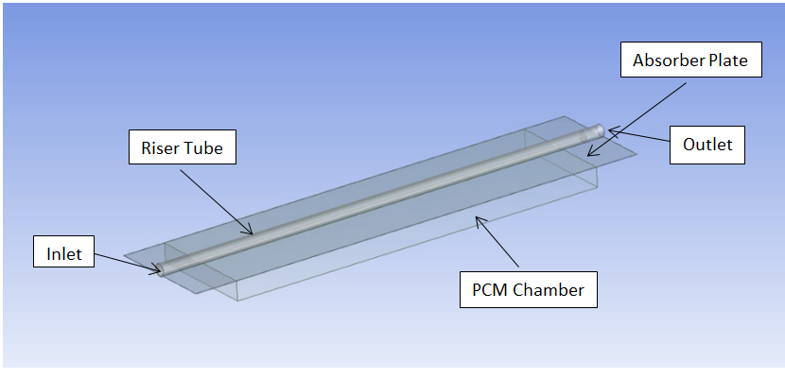

**Figure 2: Compuational domain**

*Boundary condition & initial condition:*

Initially temp. of all domain set to atmospheric temp. by patching all domains to 300 K temp. Pressure Inlet & pressure outlet boundary condition is used for fluid flow. For density variation, Boussinesq approximation model is enabled. Solidification & melting model is also enabled to capture charging & discharging process. Profile file of solar flux data has been made to give boundary condition of heat flux to upper surface of absorber plate.

SIMPLE pressure velocity algorithm and Body force weighted scheme are adopted for the pressure correction equation.

*Validation of results:*

Numerical results are compared with experimental results for three different tilt angles. From fig. 3, it is noticed that there exists some difference (max 2%) between the experimental & numerical results. The reason behind the gap could be the numerical analysis employs perfect insulating conditions & complete heat transfer from absorber plate to PCM & from absorber tube to absorber fluid. However, the trends of both curves are consistent.

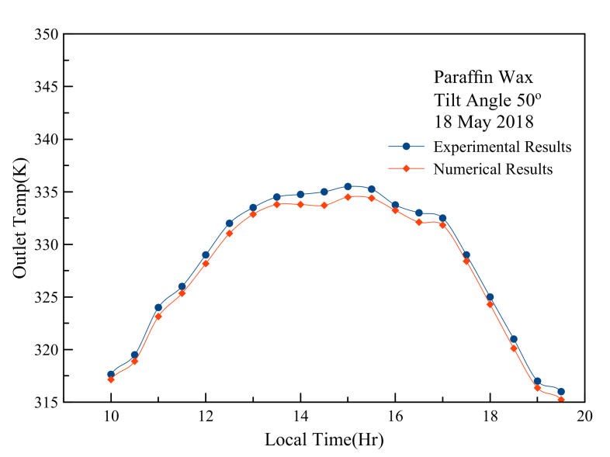

**Figure 3: Validation of numerical results with experimental results.**

# RESULTS AND DISCUSSION

Fig. 4 & 5 show the melting and freezing process of PCM. From fig. 4, it is noticed that PCM starts melting from region near the outlet where heat transfer to heat transfer fluid is minimum. Nearly 180 minutes required for charging process & 140 minute for discharging process. During discharging, PCM releases latent heat at constant temp. So, absorber plate gets heated ever after sunshine period during freezing process of PCM. In this way, we get more useful heat gain and efficiency from the collector. The variation of instantaneous efficiency with respect to time is as shown in fig. 6.It is observed that instantaneous efficiency of conventional solar collector was found to drop after peak hours but for the collector with PCM acceptable efficiency was found as PCM act as heat source.

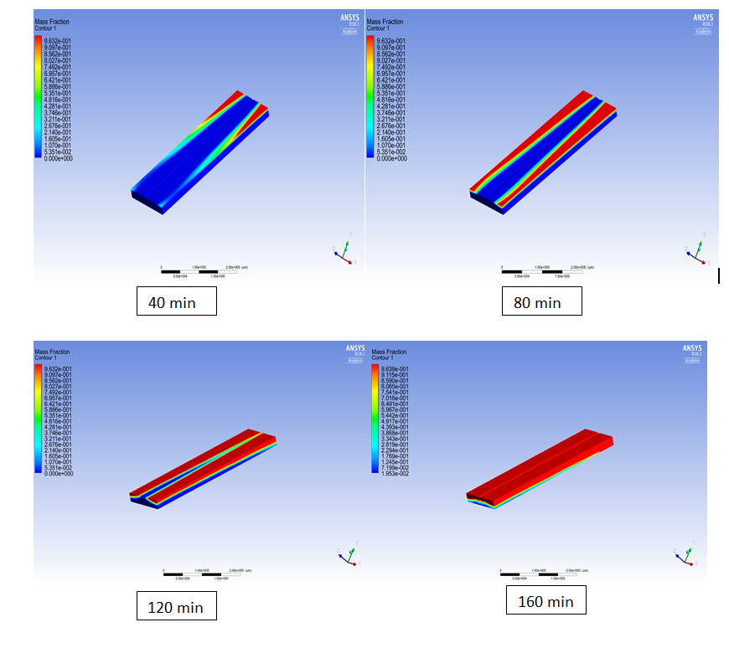**Figure 4: Charging Process of PCM**

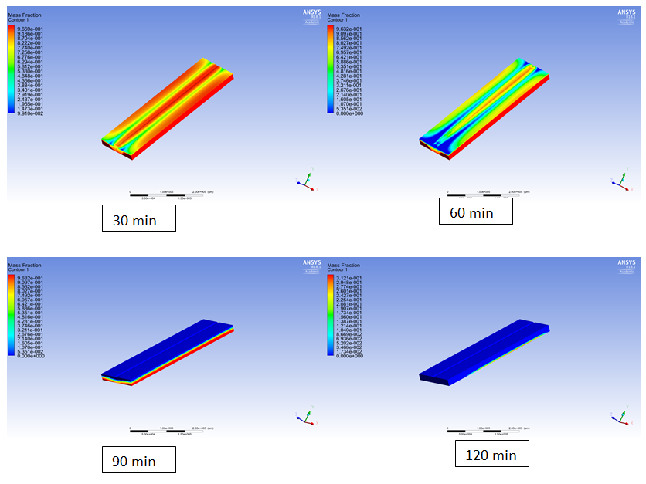

**Figure 5: Discharging Process of PCM**

The variation of instantaneous efficiency with respect to time is as shown in fig. 6.It is observed that instantaneous efficiency of conventional solar collector was found to drop after peak hours but for the collector with PCM acceptable efficiency was found as PCM act as heat source.

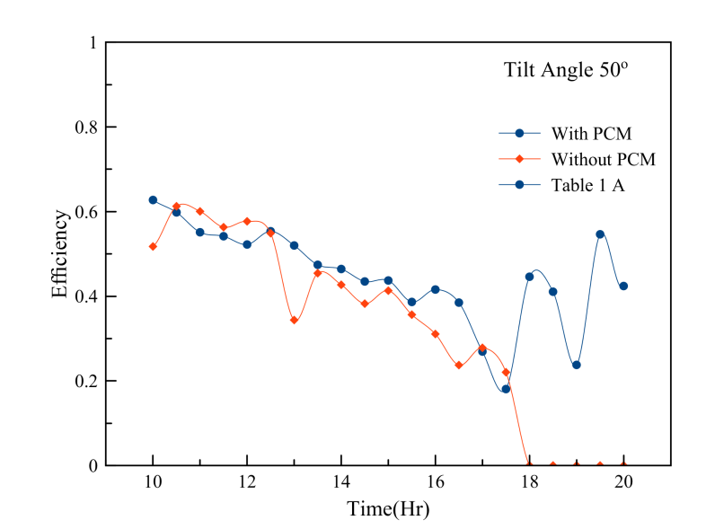**Figure 6:The variation of instantaneous efficiency with respect to time**

Fig. 7 shows comparison of total efficiency of conventional collector with PCM integrated collector. The efficiency for both the collectors was found low at lower tilt angle & it increased with increase in tilt angle upto 50°. Increasing tilt increases buoyancy force on heat transfer fluid. Due to increase in buoyancy force there will be increase in Rayleigh number. Higher the Rayleigh number, higher will be Nusselt number. Therefore heat transfer increases and thence efficiency.

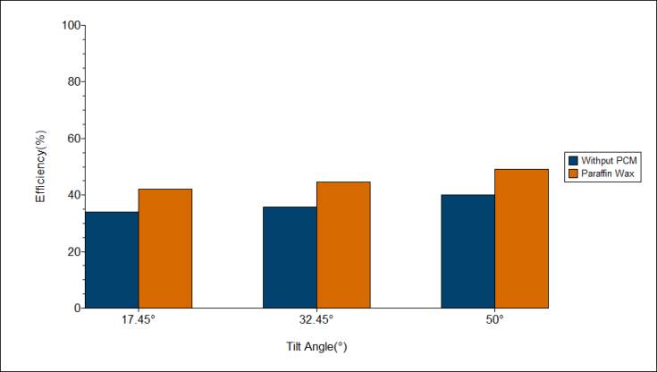

**Figure 7: Total efficiency comparison with PCM.**

# CONCLUSIONS

Back layer PCM configuration is studied to enhance the performance of conventional collector. Collector with 50° tilt angle gives optimum results. For the same environmental condition it gives 25.64 % improvement in total efficiency. During off-sunshine hour heat carried away by the heat transfer fluid for collector without PCM is almost negligible while for collector with PCM heat carried away by the heat transfer fluid is considerable because PCM acts as heat source during off sunshine period.

**Acknowledgements**

I am grateful to Dr. S.S. Mohite (HOD, mechanical engineering, GCEK) for providing necessary facility to conduct numerical work.

**References**

1. J.Prakash, H.P. Garg, G. Datta, A solar water heater with a built-in latent heat storage, Energy Conversion & Management, 25 (1985) 51-56.
2. A.J. Khalifa, K. Suffer, M.S. Mahmoud, A sorage domestic solar hot water system with a back layer of phase change material, Experimental Thermal & Fluid Science, 44 (2013) 174-181.
3. M. Carmona, G. Caicedo, H.G. Vega, A. Bula, Reduced Model for a Thermal Analysis of a Flat Plate Solar Collector With Thermal Energy Storage Using Phase Change Material (PCM).ASME International Mechanical Engineering Congress and Exposition, Volume 6B (2015).
4. M.S Mohsen, A. Al-Ghandoor. I. Al-Hinti, Thermal analysis of compact solar water heater under local climatic conditions, International Communications in Heat and Mass Transfer, 36(2009) 962-968.
5. A.V. Waghmare, A.T.Pise, Numerical investigation of concentric cylinder latent heat storage with/without gravity and buoyancy, Energy Procedia, 75(2015) 3133-3141.
6. M.Redzuan, C.N. Saw, H.H. Al-Kayiem, A. Lukmon, NUMERICAL SIMULATION OF PCM INTEGRATED SOLAR COLLECTOR STORAGE WATER HEATER, ARPN Journal of Engineering and Applied Sciences, 12(2017) 3363-3367.
7. A. Luca, Tagliafico, S. Federico, D.R. Mattia, Dynamic thermal models and CFD analysis for flat plate thermal solar collector – A review, Renewable and Sustainable Energy Reviews, 30(2014  
   ) 526-537.
8. D. Henderson, H. Junaidi, T. Muneer, T.Grassie, J. Currie, Experimental and CFD Investigation of an ICSSWH at various inlinations, Renewable and Sustainable Energy Reviews, 11(2007) 1087-1116.
9. J.A. Duffie, W.A. Beckman, Solar Energy of Thermal Processes, John Wiley and Sons Inc., New York, 2006.