**Enhancing Mobile Networks with SDN Using Spectrum Allocation and Malicious Detection in CRN**

**P Divya**

*PG student,*

*Dept of Electronics and Communication,*

*Annamalai University,*

*Chidambaram, Tamil Nadu*

**Dr.P.Kailasapathi**

*Professor,*

*Dept of Electronics and Communication,*

*Annamalai University,*

*Chidambaram, Tamil Nadu*

**Abstract**

Increase in number of commodity devices using network connection raised the spectrum demand largely. The present static spectrum allocation policy gave birth to the so called spectrum scarcity problem. Cognitive Radio enhances the bandwidth usage through Dynamic Spectrum Accesswithout affecting the allocated spectrum, therefore offers a feasible solution to the problem of spectrum scarcity. Enhancing the spectrum usage efficiently, cognitive radio technology allows secondary users to acquire underutilized licensed spectrum band. Smooth spectrum mobility in cognitive radio networks is extremely necessary to ensure the continuity and quality of service. This work aims to develop a dynamic horizontal handoff strategy that adopts according to the traffic pattern of PU. Proposed model keeps track of mobility patterns on certain primary spectrum and classifies these spectrum channels based on primary user’s arrival on them. Handoff strategy decision is based on these classified patterns, which can be either proactive or reactive strategy. To improve our proposed work ,we are adding advantages of malicious detection in the network and also Several ideas to increase the functionality and capacity of wireless network using software defined net working(SDN) and cloud computing technologies.

Keywords—cognitive radio network (CRN); software defined networking(SDN);dynamic spectrum access (DSA);malicious detection;handoff stretegies.

I. INTRODUCTION

CRNs give the most promising solution to spectrum scarcity problem through dynamic spectrum access (DSA). CRNs can enhance the efficiency of the bandwidth utilization without changing the governmental regulations by allowing secondary user to occupy the underutilized licensed spectrum band of PU opportunistically, therefore provides a most feasible solution to the problem of spectrum scarcity [1]. CRN performs four functions in spectrum management framework (SPM) known as spectrum sensing, spectrum decision, spectrum sharing and spectrum mobility/handoff. Spectrum sensing is the finding for spectrum holes by CR node for the communication of SU in licensed spectrum. Spectrum decision is the selection of best channel for communication. Spectrum sharing is the coordination of channel access between CR nodes. Among all these function the most important and challenging function is spectrum mobility where a SU suspends its ongoing transmission on the licensed spectrum band and vacates it as the PU reclaims its own licensed spectrum hole. SU has to look for a new vacant channel to continue its suspended communication. The idea behind the spectrum mobility is to minimize the degradation in performance during the handoff process through fast and smooth transition [2] in CRNs. Several Spectrum handoff techniques have been proposed, generally based on spectrum sensing and channel selection capabilities such as non-handoff, proactive handoff, reactive handoff and hybrid handoff. In non-handoff technique, SU keeps waiting in the occupied channel until the PU complete its transmission and the channel becomes free again. In proactive handoff technique SU selects the target channel and performs the handoff actions before the handoff activating event happens. So accessibility of target channel is ensured way before the transmission on ongoing observations results [3]. In reactive handoff the target channel is selected only after the handoff triggering event is occurred. This technique offers accuracy of the selected target channel but on the price of sensing time as the selection is made from the results of on-demand wideband sensing [4]. In Hybrid handoff technique both reactive and proactive strategies are combined by using proactive spectrum sensing and reactive handoff action. Target channels selection is done prior to SU transmission and spectrum handoff is performed after the triggering event occurs [5]. Different spectrum handoff algorithms are used in CRNs based upon above mentioned strategies characterized by backup channel, handoff delays, QoS and their efficiency. Spectrum sensingand sharing have already been dealt in great detail in existing literature [13-16]; therefore we focus on spectrum mobility/handoff concerns. Spectrum handoff occurs when the PU appears on its licensed bandwidth temporally occupied by the SU. SU must then have to search for another vacant channel to continue its transmission. When a vacant channel is found, the SU can resume its transmission on the newly available spectrum portion however problems such as packet loss, delay and jitter can arise during this handoff process [2]. In this work, we propose an adaptive spectrum handoff algorithm which is sensitive to primary user’s arrival patterns on its licensed spectrum. Proposed framework first classifies each available channel based on primary user’s activity on that channel. If the primary user acquires and leaves the spectrum quite frequently, such scenario required a proactive handoff strategy whereas if PU is not frequent then reactive handoff strategy performs better. It efficiently minimizes channel under-utilization and handoff delays with our proposed adaptive spectrum handoff algorithm.

# **LITRATURE REVIEW**

Generally, spectrum handoff is categorized into two types, the proactive handoff and the reactive handoff [28]. In proactive handoff strategy, the next channel for data communication is determined according to the detected traffic patterns of a PU, before the handoff triggering event. In reactive handoff strategy, the target channel is selected by instant sensing after the occurrence of handoff event. The SU can resume its unfinished transmission on newly searched channel. Proactive handoff technique can be further classified into three types depending upon channel backup: full backup that always keep a backup channel with the current transmission channel, No backup that does not have any backup channel and compromise between full backup and no backup [29]. A Short Time Backup Channel strategy (STBC) based upon proactive handoff decision is proposed by [29] that is a compromise between full backup and no backup. The SU selects the target channel by proactive decision and keep it as backup for a short time then after some time if the transmission becomes stable on the current channel; the backup channel is released and in full back up channel is not released. STBC overcomes this problem by keeping the target channel for a short time and the handoff delay is also decreased as the channel is pre-selected. Demerits of this strategy are complexity and selection of optimal target channel in case of pre-selected channel no more available. Another proactive handoff decision based approach is fuzzy approach for spectrum handoff [30]. This strategy focuses on the spectrum handoff decision for SU based upon fuzzy logic algorithm. The main purpose of fuzzy logic is to handle problems more efficiently as compared to other mathematical models. The main advantages of this strategy are that it is based upon fuzzy logic so it provides an efficient estimation of the parameters and maximized channel utilization. A cumulative probability based handoff scheme to reduce the number of handoffs in order to meet better QoS (Quality of Service) is proposed by [31] which is also a proactive handoff approach. Dynamic Frequency Hopping Communities (DFHC) proposed by [9] to increase IEEE 802.22 performance is a reactive handoff scheme. In this strategy, a WRAN (wireless regional area network) cell or SU while communicating on current channel observes availability of the next target channel. Then to avoid collision with PUs, the SU hops on target channel in order to continue its transmission and starts sensing the previous channel. Different techniques for the prediction of traffic pattern in CRNs are proposed in [32]. These techniques are used to determine the best suitable frequency band for SU transmission after examining the PUs traffic pattern. In CRNs traffic pattern prediction minimizes the number of handoffs for SU and also reduces interference on PU. Authors in [33] propose an algorithm for call arrival rate prediction of PU based on data analysis of traffic characteristics and characterized in patterns for a single user’s behavior using clustering techniques in an established network. These clusters are than used to develop a prediction approach for network traffic. Auto class and k means algorithms are used for identifying clusters and SARIMA model is used for network traffic forecasting. Prediction of network traffic with variable users is possible through developed prediction approach and also provides the facility of network expansion. A method for systematic traffic forecasting based on environment information and user’s properties is proposed in [34]. A newer method employing exogenous variables which is based upon multiple regression mechanism for a time-series is adopted. Authors of [35] propose a fuzzy logic based algorithm for spectrum handoff which can perform two significant functions, first is the adjustment of SU transmission power which helps in avoiding handoff through minimizing the interference upon PU, second is to take the decision of handoff after analyzing the different parameters, which may include Holding Time (HT). To minimize the influence of spectrum usage switching & termination, Minimum-interference-robust-topology construction (MIRTC)is the main problem [36].

In a control system based upon fuzzy logic is proposed in which CR can vary the transmission power by measuring the distance, interference and node density between corresponding sender andreceiver. Spectrum Sensing observes the status of spectrum occupancy and analyze the availability of channel. The CR users access the channels dynamically through spectrum decision, sharing and mobility’s regulation processes. A mobility management method based upon spectrum awareness is proposed in [37]. In first step to minimize the heterogeneity in spectrum availability network architecture is proposed, which is then used to develop a management framework to support increasing mobility events such as spectrum mobility and user mobility. Fuzzy-Analytic-hierarchy-Process (FAHP) is applied during decision process for spectrum handoff in CRNs .

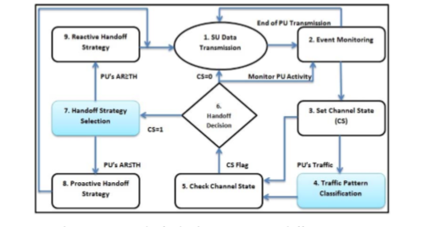

Fig. 1. Framework of adaptive spectrum handoff strategy

# **PROPOSED WORK**

***A*. *Traffic Pattern Based Handoff Strategy***

Traffic prediction of PU’s helps to apply the best suited handoff strategy in CRN’s. Proposed model uses traffic pattern trends of available channels to classify them as periodic traffic and random traffic patterns. We aim to predict the future traffic pattern of different channels for handoff process, so that we may apply best suited handoff strategy accordingly. Figure 1 illustrates the proposed framework for PU’s traffic pattern prediction based Adaptive handoff strategy. Step-1; secondary cognitive users on the current channel performs couple of functions including data transmission and PU’s event monitoring, which is necessary for the traffic prediction. Step-2; Gathered information is then stored in history database. Usually the final event information tells the current status of the channel. Flag of the Channel State (CS) is set as 0, if the channel observed is free and CS is set as 1 if not free. Step-3; Using classification threshold method [26], traffic pattern of channels are classified as periodic and random. Service time depends on amount of recent traffic pattern information available for that channel. Traffic category can be changed during a transmission and depends on how the primary user is using the channel. Step-4; Channel state is checked prior to making the decision of handoff or staying on the current channel. Step-5; during switching decision, channels are verified, CS=0 means current channel is free and CR user can continue its transmission on current channel and CS=1 means CR has to perform handoff. Step-7; this is a very important step because here model makes handoff strategy decision according to the traffic pattern. Periodic traffic pattern has fixed ON and OFF times so proactive handoff strategy is best suited as SU already know the PU’s arrival time so will perform handoff prior to the PU’s arrival in the channel. In case of random traffic pattern, idle time is estimated through probabilities and history database means that SU will transmit continuously till any interference to the PU is experienced. Analytical results revealed the fact that selection of handoff strategies doesn’t affect the performance of the system a lot and almost both the traffic pattern has similar results with different handoff strategies, which is also shown in results section. Factor which affects the system performance of the algorithm efficiency is PU’s arrival rate. We set a threshold for the arrival rate of PU by extensive experiments, so if the PU’s arrival rate is less than threshold value Proactive Handoff strategy shows the better results and with the increase in arrival rate Reactive Handoff strategies are better. In a situation when current PU do not have any history then, history of previous PU around that area and real time observation will be used to detect the traffic pattern. Data analysis of traffic characteristics for a single user can be done through clustering technique also. Figure 2 illustrates the SU’s behavior during the handoff process. Starting from event monitoring, this is the spectrum learning and information gathering for preserving historical traffic trends. Information of monitoring will be stored in database in bit format. In the next step sensed traffic will be sectioned as periodic or random traffic pattern by the use of classification function proposed in [25]. Availability time will be predicted to check the channel state if CS=0, SU will not perform handoff and continue its transmission and if CS=1, SU will perform handoff. In the final stage handoff strategy will be adopted by the SU according to the PU’s arrival rate. We divide the SU’s activity on the current channel into two time slots as ON period and OFF period. If primary user is detected, CS is set to one and the detected traffic is classified into periodic and random traffic by using classification function. CS is set to zero and SU continue its transmission on current channel if there is no PU traffic. In case of PU arrival, SU has to perform handoff and during this process it has to select the most appropriate handoff strategy to enhance the system throughput and efficiency while decreasing the handoff delay and interference to the PU.

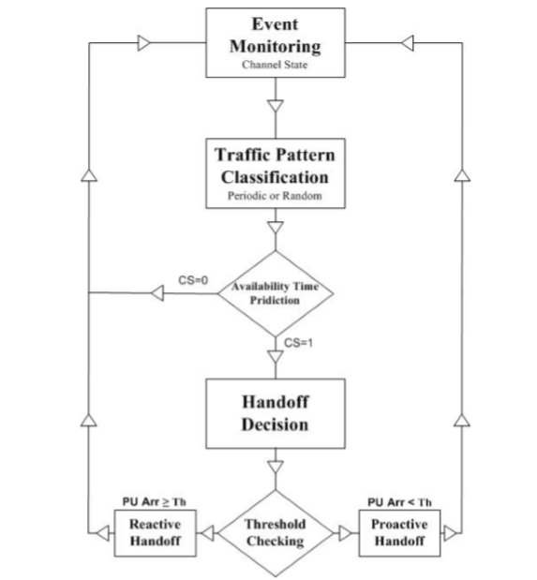

Fig. 2. SU’s Behaviors During Handoff Process

Handoff process is the most significant factor in proposed strategy that is based upon the PU traffic pattern classification. As in case of periodic traffic, ON and OFF periods are of fixed lengths in our case so SU can exactly predict the traffic pattern and in this case the Proactive Handoff strategy is best suited. During periodic traffic pattern, SU transmits its data during ON period and start sensing once transmission is over and OFF time starts. So it can exactly detect the PU arrival time and can perform handoff prior to PU arrival using proactive handoff strategy. On the other hand traffic is distributed in random pattern and usually traffic is predicted using history database and probabilities so SU may not exactly know the PU arrival time and it can also continue its transmission on channel till any interference to PU is experienced. Once PU arrives or interference exceeds from a threshold SU will perform handoff by adopting reactive handoff strategy. But as mentioned earlier performance of the algorithm varies with the PU’s arrival rate so if the PU’s arrival rate is less the threshold value proactive handoff strategy will be used and in case of greater arrival rate reactive handoff strategy will be preferred.

***B. A Software Defined Mobile Network with Cloud Computing***

As discussed above, the stringent latency constraints on 5G mobile networks call for extensive replications of resources and NE, which in turn add more burdens to network capacity and make traffic routing more complicated. Complex routing is one of the major impetus for the SDN paradigm, and the high costs of flexible resource/NE replications greatly benefit from cloud computing. Therefore, we propose an SDN framework with cloud computing to address the challenges of next generation mobile networking.

*1)Fine-Grained Traffic Steering in a Software Defined Network:*In an SDN, the control plane and the data plane are decoupled, which allows for centralized routing decisions and distributed packet forwarding. The control plane of the network is aggregated in an SDN controller which communicates with the routers using a standard interface like Open Flow. Typically, a special request or the first packet is sent to the SDN controller for each new flow, and the following operations are done by the SDN controller:

*Policy Lookup:* The policy table at the controller deter- mines the logical sequence of NE that the packets in the flow have to pass to satisfy the policy requirement.

*Flow Steering:* The SDN controller maps this logical sequence of NE into the physical network according to certain QoS requirements and optimization criteria.

*Route Installation:* Once this logical path is mapped into the physical path, the SDN controller makes changes in the forwarding table on all the routers in the path so that all packets in the flow are routed along the desired path.

1. **RESULT AND DISCUSSION**

Discussion in this section is based on comprehensive analytical analysis in order to reveal the performance of proposed adaptive spectrum handoff strategy and also implemented SDN and Malicious detection. Parameters include handoff delay, PU arrival rate, total service time, data delivery rate, throughput and channel utilization.

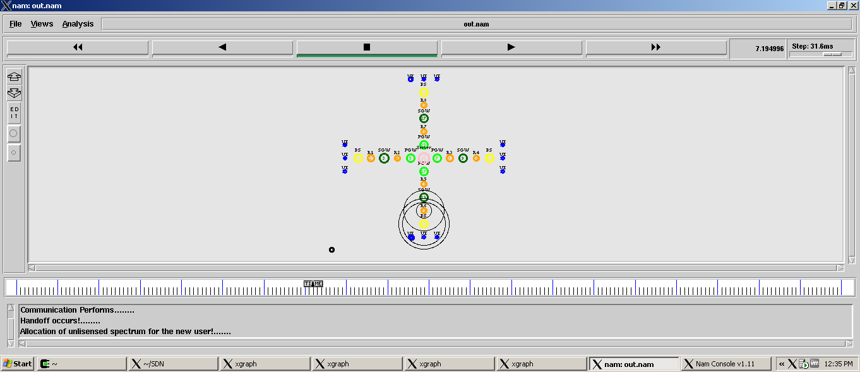

Fig.3

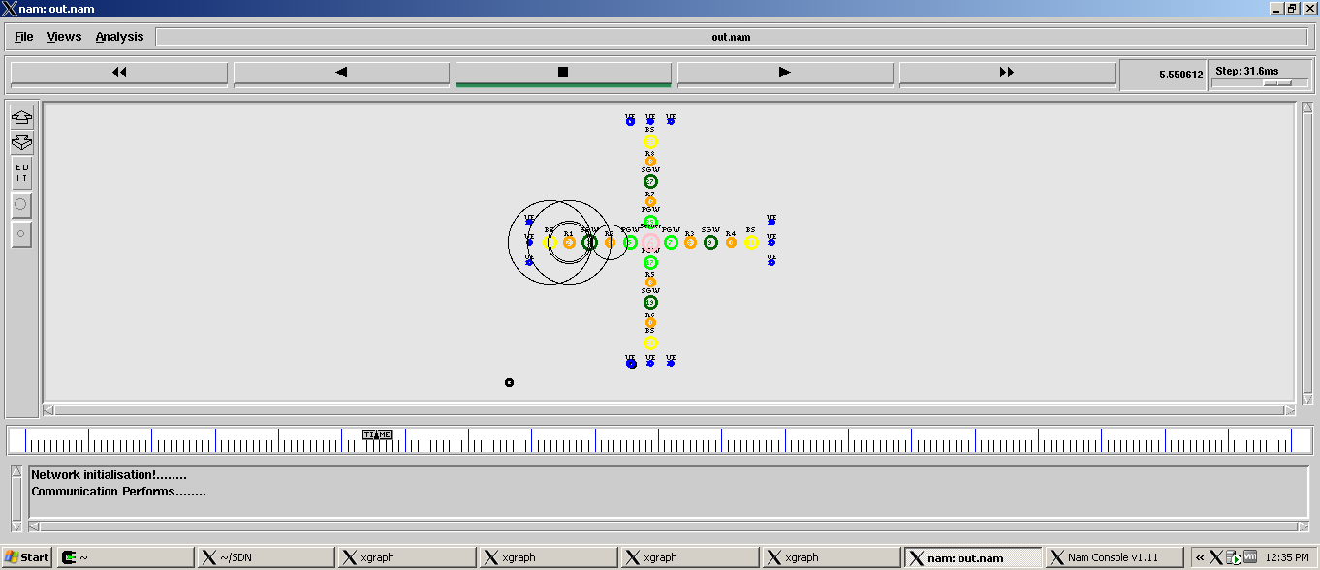

Fig.4

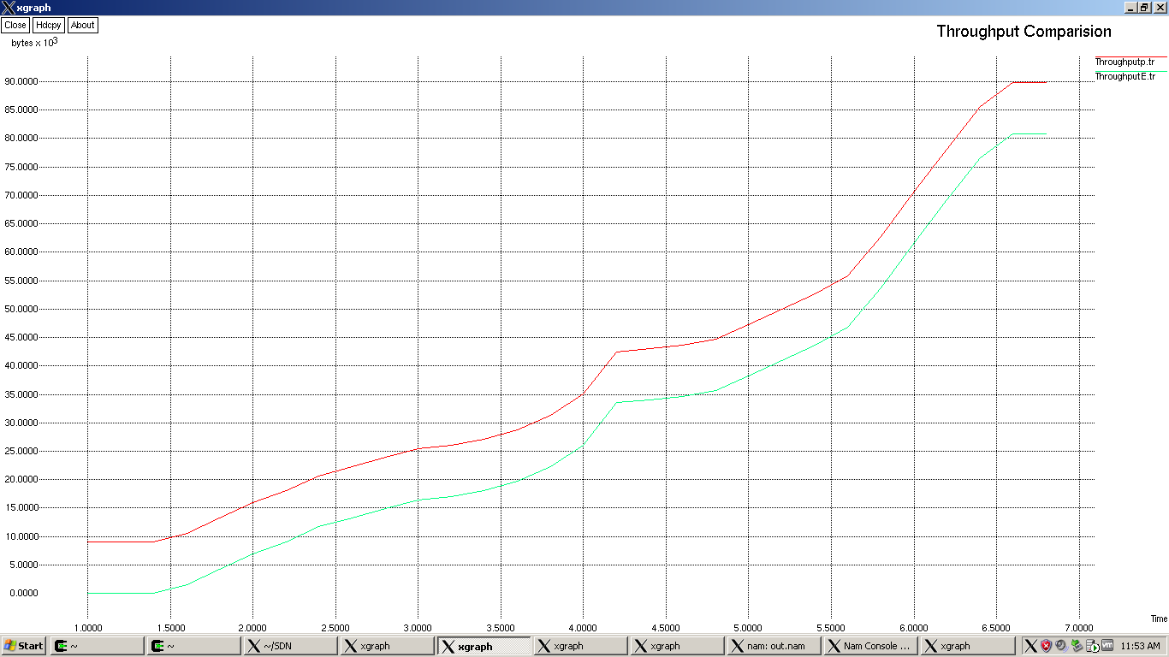

Fig.5.Throughput

Figure 5 shows the throughput comparison between proposed adaptive handoff strategy and the current static handoff strategies. Static handoff strategies are those where only PU is allowed to transmit data, whereas SU has no space for their transmission even if there are free channels available. As our proposed adaptive handoff scheme is dynamic so both the PU and SU can utilize the channel efficiently. It also is evident that static strategies has clearly lower throughput rate due to their approach which only allows PU to transmit. At other hand adaptive handoff strategy has higher throughput rate because of the efficient spectrum utilization.

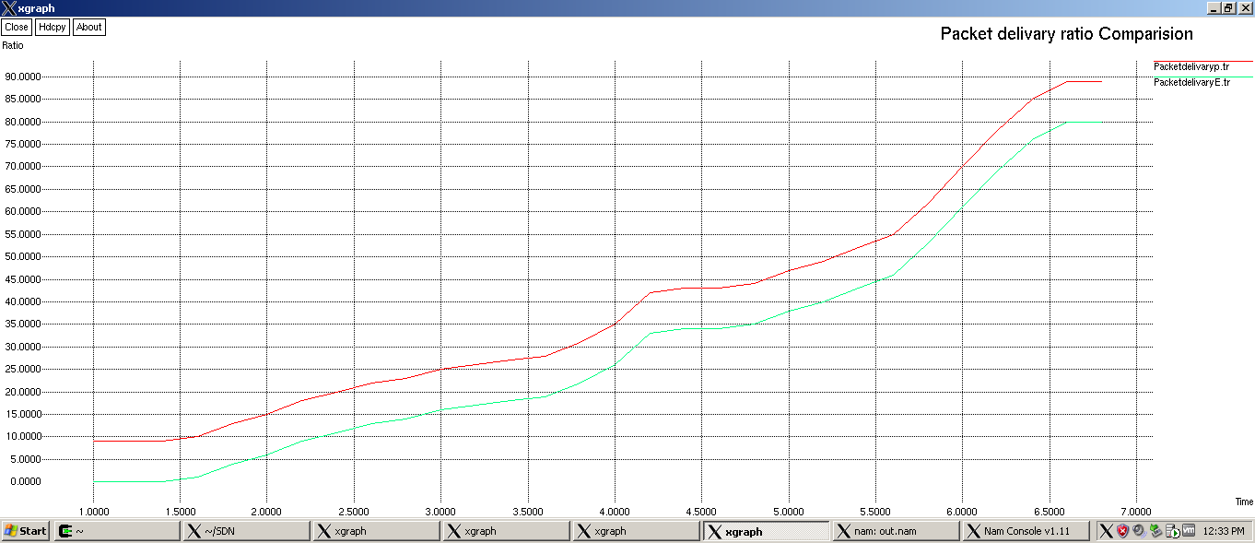

Fig.6.Packet Delivery

Figure 6 shows that comparison of packet delivery, where red curve shows proposed system which the packet delivery is high, where as the existing system shows the curve of green, which the packet delivery is less.

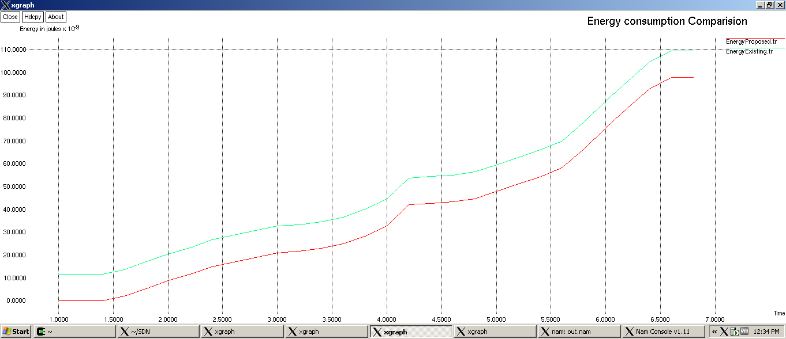

Fig.7.Energy consumption

Fig 7 shows the comparison of energy consumption, as same as above red curve shows proposed system, and energy is less as compared to existing system as shown in green curve.

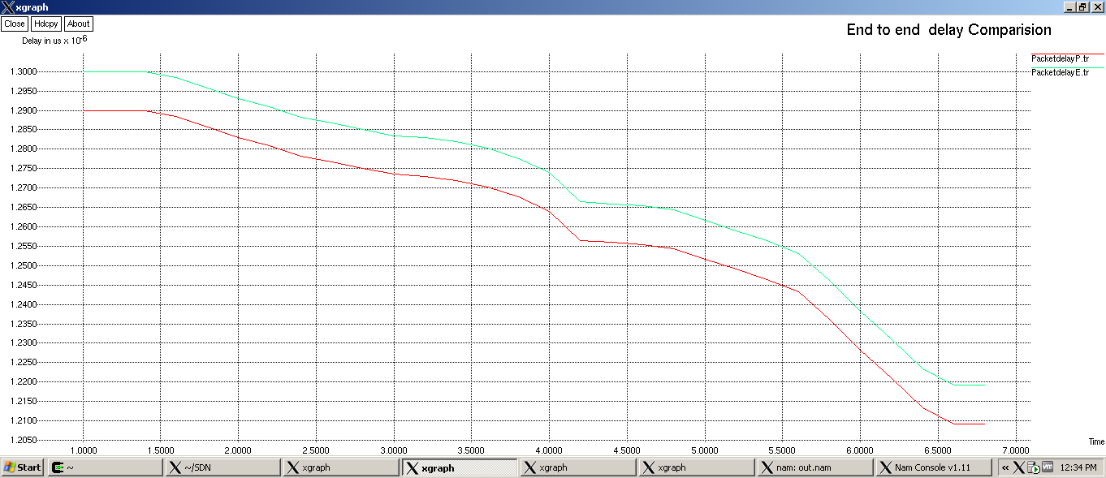

Fig.8.End to End delay

Figure 8 shows that comparison of End to End delay, where red curve shows proposed system which the delay is less, where as the existing system shows the curve of green, which the delay is high.

1. **CONCLUSION**

In this work, we develop a novel spectrum handoff strategy in CRNs. Firstly; we proposed a model in order to characterize the spectrum usage behavior of primary on its licensed band. We then proposed an adaptive horizontal handoff scheme in which secondary user intelligently shifts between proactive and reactive handoff modes. This decision is made on the basis of historical traffic pattern trends on that spectrum channel. Thus, the adaptive scheme utilizes the advantages of both reactive and proactive approaches whenever required. Simulation results shows that the proposed adaptive approach can efficiently reduce the number of unproductive handoffs and total service time of an SU while maintaining the channel utilization at maximal level. This work is a novel attempt for proposing adaptive handoff strategy and also exploits knowledge of primary arrival trends and traffic patterns for optimizing channel utilization. and also we improved our proposed work by adding advantages of malicious detection in the network. Then, we increased the functionality and capacity of wireless network using software defined net working (SDN) and cloud computing technologies.

**REFERENCES**

[1] Christian, Ivan, Sangman Moh, Ilyong Chung, and Jinyi Lee. "Spectrum mobility in cognitive radio networks." Communications Magazine, IEEE 50, no. 6 (2012): 114-121.

[2] Akyildiz, Ian F., Won-Yeol Lee, Mehmet C. Vuran, and Shantidev Mohanty. "A survey on spectrum management in cognitive radio networks." Communications Magazine, IEEE 46, no. 4 (2008): 40-48.

[3] Wang, Chung-Wei, Li-Chun Wang, and Fumiyuki Adachi. "Modeling and analysis for proactive-decision spectrum handoff in cognitive radio networks" Institute of Electronics, Information and Communication Technology Research Report. RCS, Radio communications system 109, no. 164 (2009): 13-18.

[4] Wang, Li-Chun, and Chung-Wei Wang. "Spectrum handoff for cognitive radio networks: Reactive-sensing or proactive-sensins?." In Performance, Computing and Communications Conference, 2008. IPCCC 2008. IEEE International, pp. 343-348. IEEE, 2008.

[5] Yin, Cong, Xuezhi Tan, and Lin Ma. "A hybrid handoff strategy based on dynamic spectrum aggregation in cognitive radio system." In TENCON Spring Conference, 2013 IEEE, pp. 213-217. IEEE, 2013.

[6] Lertsinsrubtavee, Adisorn, Naceur Malouch, and Serge Fdida. "Spectrum handoff strategies for multiple channels cognitive radio network." In Proceedings of the ACM CoNEXT Student Workshop, p. 20. ACM, 2010.

[7] Giupponi, Lorenza, and Ana I. Pérez-Neira. "Fuzzy-based spectrum handoff in cognitive radio networks." In Cognitive Radio Oriented Wireless Networks and Communications, 2008. CrownCom 2008. 3rd International Conference on, pp. 1-6. IEEE, 2008.

[8] Lertsinsrubtavee, Adisorn, Naceur Malouch, and Serge Fdida. "Spectrum handoff strategy using cumulative probability in cognitive radio networks." In Ultra Modern Telecommunications and Control Systems and Workshops (ICUMT), 2011 3rd International Congress on, pp. 1-7. IEEE, 2011.

[9] Hu, Wendong, Daniel Willkomm, MuradAbusubaih, James Gross, George Vlantis, Mario Gerla, and Adam Wolisz. "Cognitive radios for dynamic spectrum access-dynamic frequency hopping communities for efficient ieee 802.22 operation." Communications Magazine, IEEE 45, no. 5 (2007): 8087.

[10] Li, Xiukui, and Seyed A. Zekavat. "Traffic pattern prediction and performance investigation for cognitive radio systems." In Wireless Communications and Networking Conference, 2008. WCNC 2008. IEEE, pp. 894-899. IEEE, 2008.

[11] Chen, Hao, and Ljiljana Trajković. "Trunked radio systems: traffic prediction based on user clusters." In Wireless Communication Systems, 2004, 1st International Symposium on, pp. 76-80. IEEE, 2004.

[12] Akinaga, Yoshikazu, Shigeru Kaneda, Noriteru Shinagawa, and Akira Miura. "A proposal for a mobile communication traffic forecasting method using time-series analysis for multi-variate data." In Global Telecommunications Conference, 2005. GLOBECOM'05. IEEE, vol. 2, pp. 6-pp. IEEE.

[13] Cacciapuoti, Angela Sara, Ian F. Akyildiz, and Luigi Paura. "Optimal primary-user mobility aware spectrum sensing design for cognitive radio networks." Selected Areas in Communications, IEEE Journal on 31, no. 11 (2013): 2161-2172.

[14] Sun, Hongjian, Arumugam Nallanathan, Cheng-Xiang Wang, and Yunfei Chen. "Wideband spectrum sensing for cognitive radio networks: a survey." Wireless Communications, IEEE 20, no. 2 (2013): 74-81.

[15] Zhu, Qionghua, Yuan Wu, Danny HK Tsang, and Hong Peng. "Cooperative spectrum sharing in cognitive radio networks with proactive primary system." In Communications in China-Workshops (CIC/ICCC), 2013 IEEE/CIC International Conference on, pp. 82-87. IEEE, 2013.

[16] Mir, Usama, Leila Merghem-Boulahia, and Dominique Gaïti. "Dynamic Spectrum Sharing in Cognitive Radio Networks: a Solution based on Multiagent Systems." (2010).

[17] Lala, Nisar A., Moin Uddin, and N. A. Sheikh. "Novel Spectrum Handoff in Cognitive Radio Networks Using Fuzzy Logic." International Journal of Information Technology and Computer Science (IJITCS) 5, no. 11 (2013): 103.

[18] Tseng, Po-Kai, Wei-Ho Chung, and Pi-Cheng Hsiu. "Minimum interference topology construction for robust multi-hop cognitive radio networks." In Wireless Communications and Networking Conference (WCNC), 2013 IEEE, pp. 101-105. IEEE, 2013.

[19] Bhattacharya, Partha Pratim, and Subhajit Chatterjee. "A New Fuzzy Logic Rule Based Power Management Technique for Cognitive Radio." International Journal of Computer Science and Mobile Computing (IJCSMC) (2013): 6-11.

[20] Xing, Xiaoshuang, Tao Jing, Wei Cheng, Yan Huo, and Xiuzhen Cheng. "Spectrum prediction in cognitive radio networks." Wireless Communications, IEEE 20, no. 2 (2013): 90-96.

[21] Lee, Won-Yeol, and Ian F. Akyildiz. "Spectrum-aware mobility management in cognitive radio cellular networks." Mobile Computing, IEEE Transactions on 11, no. 4 (2012): 529-542.

[22] Yi, Peng, and Zheng Yong. "A Novel Spectrum Handoff Method Based On Spectrum Reservation." TELKOMNIKA Indonesian Journal of Electrical Engineering 12, no. 1 (2014): 653-660.

[23] Kingman, John Frank Charles. Poisson processes. Vol. 3. Clarendon Press, 1992.

[24] Kumar, Krishan, Arun Prakash, and Rajeev Tripathi. "Spectrum handoff in cognitive radio networks: A classification and comprehensive survey." Journal of Network and Computer Applications (2015).

[25] Hossain, Ekram, Dusit Niyato, and Dong In Kim. "Evolution and future trends of research in cognitive radio: a contemporary survey." Wireless Communications and Mobile Computing 15, no. 11 (2015): 1530-1564.

[26] Zeeshan, Muhammad, Muhammad Fahad Manzoor, and Junaid Qadir. "Backup channel and cooperative channel switching on-demand routing protocol for multi-hop cognitive radio ad hoc networks (BCCCS)." In Emerging Technologies (ICET), 2010 6th International Conference on, pp. 394-399. IEEE, 2010.