MODELING AND ANALYSIS, LIFE EVALUATION OF IMPELLER OF SUBMERSIBLE PUMP TO IMPROVE EFFICIENCY

Sunilkumar P.G. Student
Department of Mechanical Engineering
Don Bosco institute of technology
Bengaluru, India
Sunilkumarsonkere1@gmail.com

Raghu T
Assistant Professor,
Department of Mechanical Engineering
Don Bosco institute of technology
Bengaluru, India
Raghu12586@gmail.com

Abstract— A pump is a device that moves fluids (liquids or gases) or sometimes slurries, by mechanical action. Pumps operate via many energy sources, including manual operation, electricity, engines, or wind power. Present work on impeller of a submersible pump and design optimization by impeller of pump is carry out using analytical approach and FEM approach. Base model of a impeller is Modeling using Unigraphics and analysis (FEM ANYS)using work bench 14.5.The main Aim of work is structural analysis under static, dynamic load condition, vibration analysis, model analysis, high cycle fatigue analysis with life evaluation impeller of a submersible pump.
FEM approach is evaluated by analytical method carry out in work. The expected outcome of project reduce cost cutting and weight to the strength ratio with custom made methodology for the structural integrating of impeller of submersible pump.
Keywords- Submersible pump, impeller and vanes.

Introduction
A pump is a device that moves fluids (liquids or gases), or sometimes slurries, by mechanical action. Pump is device it may be mechanical energy into hydraulic energy is a pump. Pumps can be classified into three major groups according to the method they use to move the fluid: direct lift, displacement, and gravity pumps .Pumps operate by some mechanism (typically reciprocating or rotary), and consume energy to perform mechanical work by moving the water. Pumps operate via many energy sources, including manual operation, electricity, engines, or wind power. Other word pump may be hydraulic energy into mechanical energy or mechanical energy into hydraulic energy. It assists to increase the pressure energy or kinetic energy. or both of the fluid by converting the mechanical energy. The basic difference between a turbine and pump, from hydrodynamic point of view, is that in the former flow takes place from the high pressure side to the low pressure side, whereas in pump flow takes place from the low pressure towards the higher pressure. Thus in a turbine there is accelerated flow, while in a pump, the flow is decelerated. The Submersible Pump main application is agriculture, wind power, industries and water tank etc.
Impeller trimming is a common practice performed by pump manufacturers and users when it is necessary to adjust the centrifugal pump head and flow for the actual requirements. The impeller trimming is not strictly similar to the initial pump because only a few parameters are modified, while all the others remain unchanged. [1].
The flow pattern and power number in a vessel depend on the impeller blade angle, number of blades, blade width, blade twist, blade thickness, pumping direction and interaction of flow with the vessel wall. The effect of impeller design on the flow pattern and mixing time for a set of axial flow impellers have been studied by varying various parameters for impeller geometry. A very good agreement has been observed between experimental and the predicted mixing time over a wide range of impellers [2]
- OBJECTIVE
- Using analytical equations, geometric model is developed
- Static structural analysis of impeller of submersible pump
- Vibration analysis of impeller of submersible pump
- Life evaluation of impeller of submersible pump
- METHODOLOYG
- Using analytical equation base line design model is developed
- Using Unigrapics and design submersible pumps modeled
- Static structural linear and bilinear analysis carryout for the certain boundary condition
- Vibration analysis is carryout the impeller submersible pump find model and natural frequency
- Life evaluation of impeller of submersible pump carry out is valuated with analytical method and FEA approach.

The submersible impeller pump
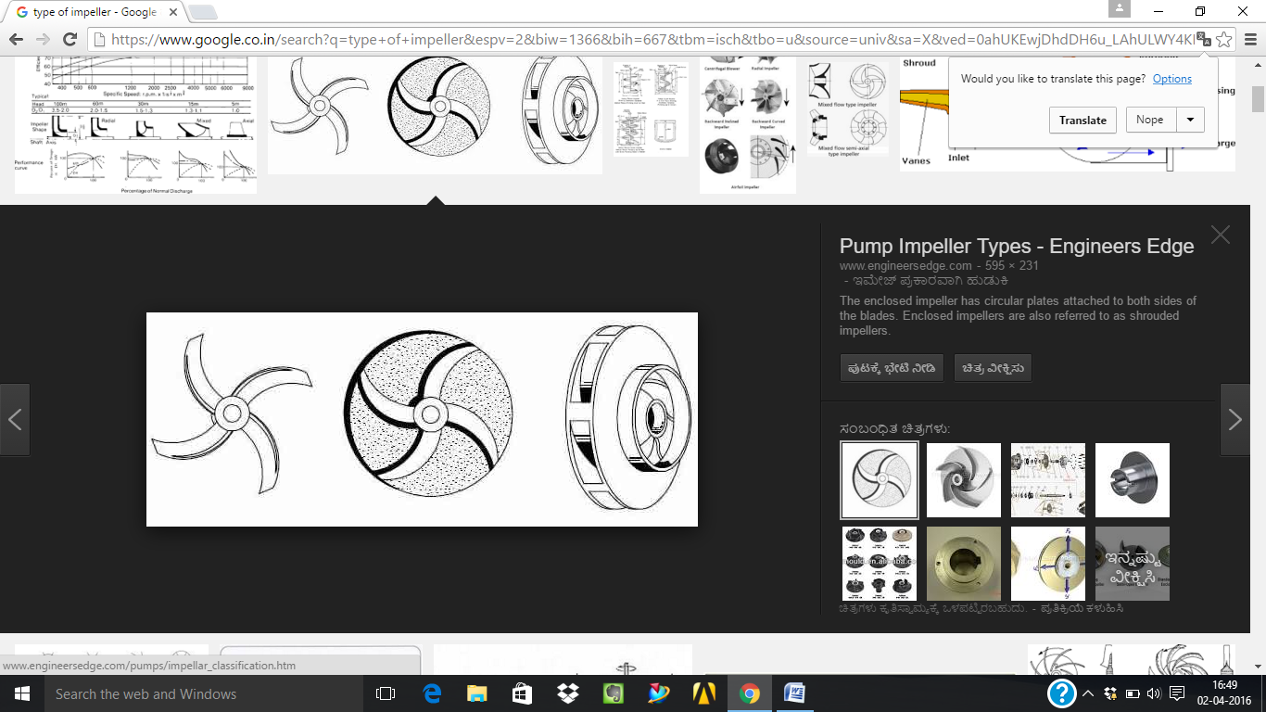
Fig 1. Submersible impeller

Table 1. Impeller data

Sl no | parameters | Dimensions
1 | Inlet diameter (D1) | 137.15 mm
2 | Outlet diameter (D2) | 297.67mm
3 | Eye inlet diameter (d1) | 80mm
4 | Eye outlet diameter (d1) | 100mm
5 | Inlet angle (ɸ1) | 23˚
6 | Outlet angle (ɸ2) | 20˚
7 | No of vanes | 8

[1].calculate pump specific speed
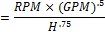 (1)
[2]. calculate impeller diameter
Head constant =1.075
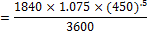 (2)

[3]. Determine eye diameter
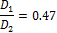 (3)
[4]. Estimate impeller eye area.
Eye area=Area at impeller eye-shaft area
=23.76-3.1=20.66 sq in.
[5].Estimate NPSHR
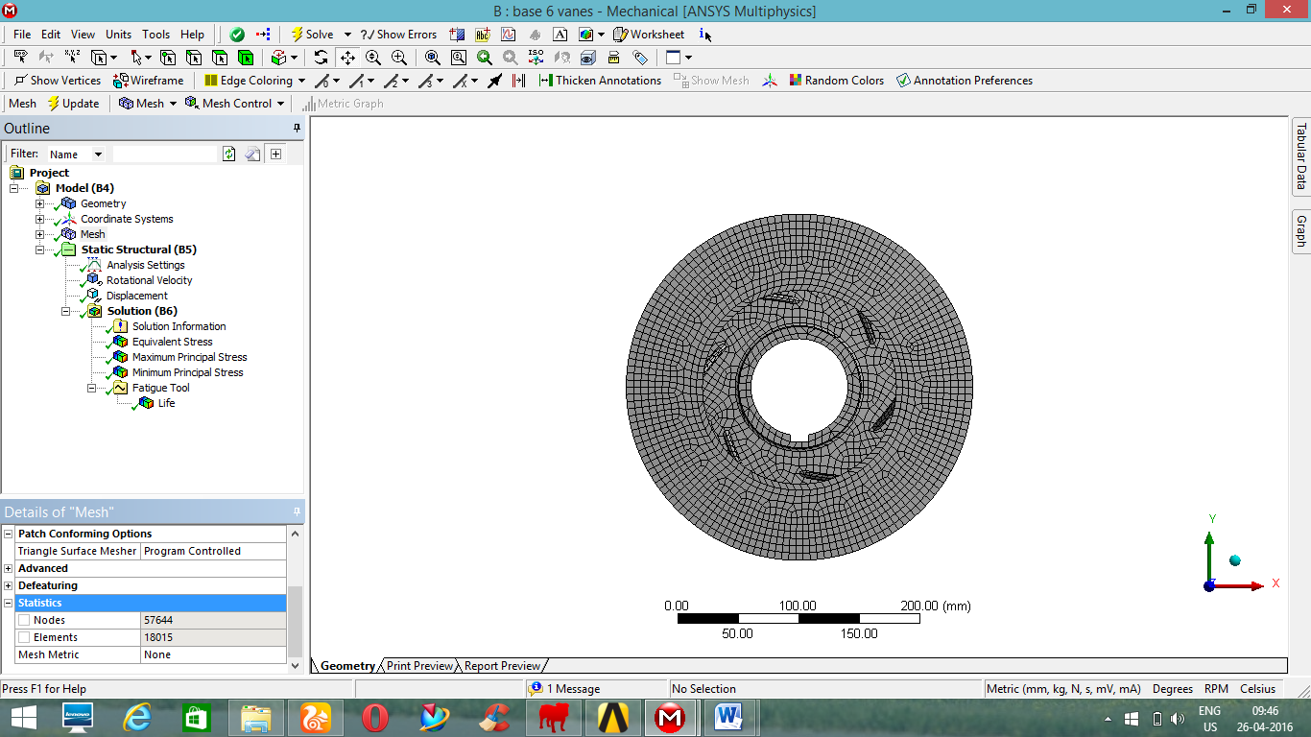
(4)
[6].Volute area (A)

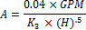

Geometric modol

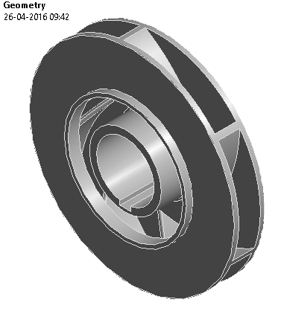

Fig2. 3D model of impeller

Mesh of impeller model
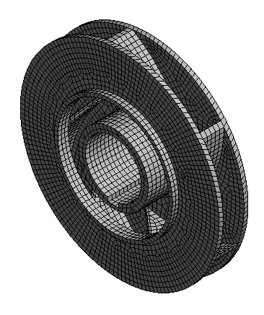

Fig3. Meshed of impeller pump
The above figure shows meshing on impeller of submersible pump. Meshing is used in hexagonal mesh metric statistic nodes is 57644 and elements 18015. Using Ansys software work bench (14.5 work benches).

Table 2. Meshed of impeller

Finite element approach
Finite element Method based upon discritization of component into Finite number of blocks (elements),Finite element method (FEM) is a numerical technique for finding approximate solutions to boundary value problems for partial differential equations. It uses subdivision of a whole problem domain into simpler parts, called finite elements, and variational methods from the calculus of variations to solve the problem by minimizing an associated error function.
Analogous to the idea that connecting many tiny straight lines can approximate a larger circle, FEM encompasses methods for connecting many simple element equations over many small subdomains, named finite elements, to approximate a more complex equation over a larger domain.

Linear Static Analysis
It is the simplest and most commonly used type of analysis
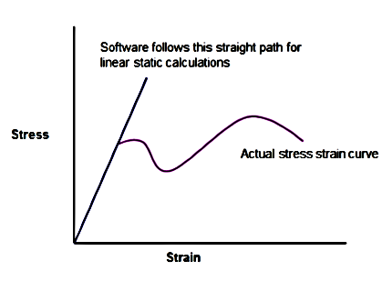

Fig4. Linear Static Approach
Linear means straight line. σ = €E is the equation of straight line (y = mx+c) passing through origin. ‘E’, Young’s modulus is the slope of curve and is a constant. In real life, after passing yield point material follows nonlinear curve but software follows same straight line. Component break into two separate pieces after crossing ultimate stress but software based analysis never show failure in this fashion.
It shows single unbroken part only with red color zone at the location of failure. Analyst has to conclude whether the component is safe or fail by comparing maximum stress value with the yield or ultimate stress.
Bilinear Kinematic Hardening
The yield criterion for many materials depends on the history of loading and evolution of plastic strain. The change in the yield criterion due to loading is called hardening and is defined by the hardening rule. Hardening behaviour results in an increase in yield stress upon further loading from a state on the yield surface so that for a plastically deforming material, an increase in stress is accompanied by an increase in plastic strain.

The linear analysis is x and y direction perpendicular (straight) to line .also bilinear analysis as x and y is average of the stress is bilinear analysis.
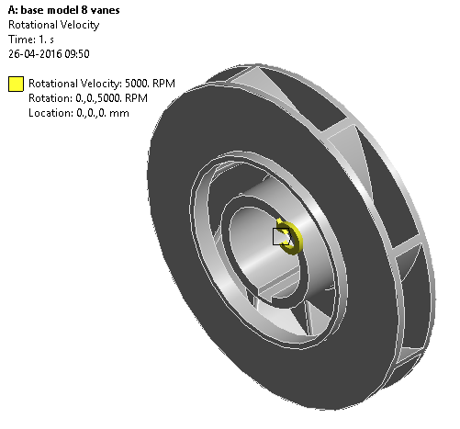
Boundary condition

Fig4. Rotational speed 5000 rpm
The rotational velocity of submersible impeller pump is 5000 rpm. It is x in zero (constraint ) rotation in z and y direction .
Gun metal physical properties
Properties | Values
Density | 8.72*10^3 kg/m^3
Young’s modulus | 103^3 mpa
Tensile strength | 310 mpa
Yield strength | 152 mpa
Fatigue strength | 90 mpa

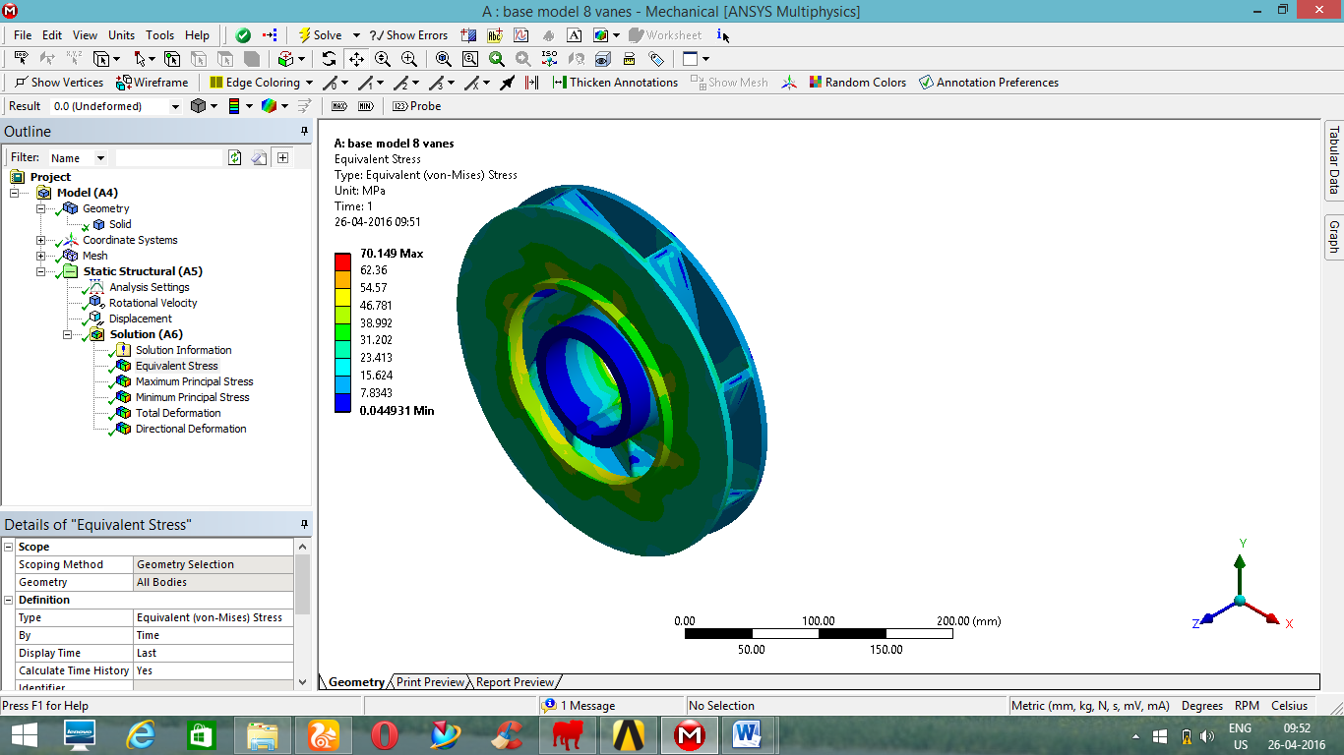
Result and observation

Fig5. Von-mises stress of impeller

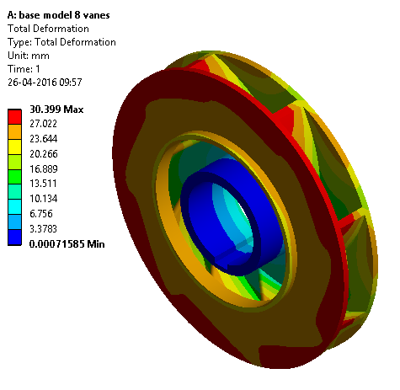

Fig6. Total deformation of impeller pump

Result and validation

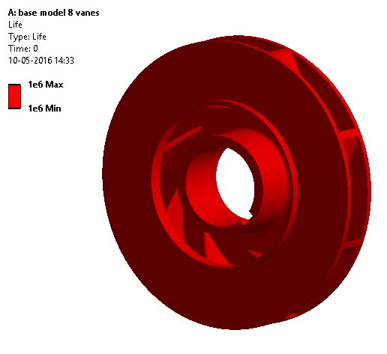

Fig6. Life evaluation of impeller

Goodman diagram
Mean Stress can be calculated from,

Where
σ_{von} = Equivalent von-Misses Stress

= 29.96 MPa

Where
σ₁= Maximum Principal Stress
σ₂= Minimum Principal Stress

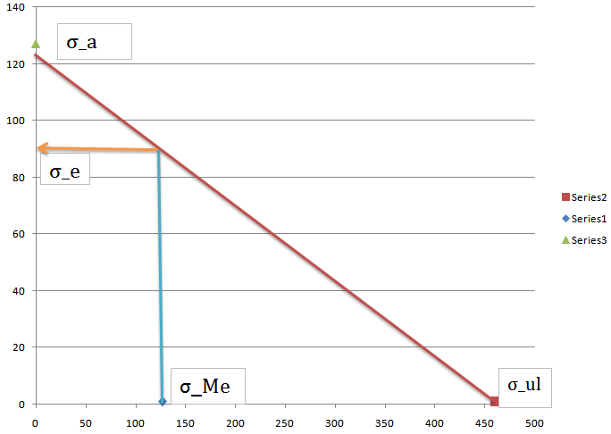
Fig7.Goodman Diagram

Number of cycles:

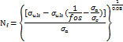
Where,
Nf=Fatigue life
σutl=Ultimate stress
Fos=Factor of Safety
σe=Endurance limit
b = Fatigue strength exponent
σa=Alternating stress

The resulting life of failure obtained by analytical method is greater than Cycles hence it is high cycle fatigue.

Conclusion
The modeling of the impeller is one critical parameter that should be the prime concern when considering the efficiency of the pump. Submersible pumps are used in clear water, sewage water and also in seas. Considering all these factors we need to model an impeller in a more practical way to suit to all these conditions. The impeller model is developed Unighaphoc software using analytical equation. The impeller is tested in ANSYS (work bench 14.5). The linear analysis is carryout equivalent and maximum is below than allowable stress it is concludes submersible impeller design is safe. Vibration analysis carryout natural frequency and model shape, to identify 6 model shape. The impeller design is comparison Gun metal and CFRP laminated material the composite material efficiency is improved. Also life validation of impeller is comparison FEM and analytical is 1.56*10^6.

ACKNOWLEDGEMENT
ACKNOWLEDGEMENT
We are grateful to Mr. Raghu T Asst. Professor, Dr.Rathnakar.G Professor and HOD ME and Dr.V.S. Ramamurthy Principal, Don Bosco Institute of Technology, Bengaluru for their cheerful encouragement and timely inspiration which helped us to complete the paper.

References
[1] Mr. Mehta Mehul P. “performance analysis of mixed flow pump impeller using cfd” international journal of emerging trends in engineering and development issue 3,pp 648-660,january 2013.
[2] Dicmas J L vertical turbine mixed flow and impeller pump ,Macgrow Hill Inc,USA, 1987,
[3] Hao Bing, Shuliang Cao,” Three-dimensional design method for mixed-flow pump blades with controllable blade wrap angle” Journal of Power and Energy,pp567-583,july 2013.
[4] [10] Tuzson John, Centrifugal Pump Design, John Wiley & Sons, INC., 2000, ISBN 0-471-361003.
[5]A.Manivannan,” Computational fluid dynamics analysis of a mixed flow pump impeller”, international journal of science and technology, vol 2 no.6, pp200-206, 2010.
[6]Sambhrat srivastav “Design of a mixed flow pump impeller and its validation using FEM analysis” Procedia Technology vol 14 ,pp 181 – 187, ,2014 .
[7]Pranit M. Patil and Sangram S. Patil” Design, Development and Testing of an Impeller of Open Well Submersible Pump for Performance Improvement”, International Journal of Science and Research,vol 3 issue 6,pp 23197064,june 2014.
[8] Arungshu Das and Apurba Kumar Roy “Design and Stress Analysis of a Mixed Flow Pump Impeller” International Journal of Mechanical Engineering and Computer Applications, Vol 1, Issue 5,pp 1-5,octo-2013.
[9] Liu J R, Zhang L S, Xiang H G, et al. 2010 J. Drain. and Irrig. Mach. Eng. 28(5) 394-97
[10] Feng J J, Benra F K and Dohmen H J 2010 J.Forsch Ingenieurwes 74(3) 123-33
[11] Zhao Yunge et al. 2012 J. Drain. Irrig. Mach. Eng. 30(3) 300-3
[12] Wei P R, Liu W W and Jian W 2010 J. Fluid Mach. 38(09) 31-34
[13] Wang F J 2004 Computational Fluid Dynamic Analysis-CFD Principle and Application (Beijing: Tsinghua University Press) p 114
[14] Launder B E and Spalding D B 1974 J.Computer Methods in Applied Mechanics and Eng. 3(2) 269-89
[15] Ferziger J H and Peric M 1996 Computational Methods for Fluid Dynamics (Berlin: Springer)
[16] Pedersen N, Larsen P S and Jacobsen C B. 2003 J. Fluids Eng. 125(1) 61-72
[17] Sinha M, Katz J and Meneveau C 2000 Trans. ASME J. Fluids Eng. 122 108-16 [10] Yuan J P, Fu Y X, Liu Y, et al 2010 J.Drain. Irrig. Mach. Eng. 28(4) 310-
[18] Course Manual on “Hydraulic Design of Mixed Flow Pump”, by SiTarc Pump Institute, Coimbatore
[19] Mody Pumps manual for pump G554T, version 1.1
[20] S. Manoharan, N. Devarajan, M. Deivasahayam and G. Ranganathan, Enriched Efficiency with Cost effective Manufacturing Technique in 3.7 kW Submersible pump sets using DCR Technology, International Journal on Electrical Engineering and Informatics

